Why Use the Classlist for Emailing?

• It ensures all enrolled students receive important announcements.
• Emails sent from Brightspace stay within the Sent Folder for the instructor and are sent to students’ Your Institution email address.

📌 How to Email Students from the Classlist in D2L Brightspace
1. Go to the Course Homepage
• Navigate to your course in D2L Brightspace.
• Click on the Classlist tool (usually in the Communications dropdown on the Navbar).
2. Select Recipients
• Check the boxes next to the students you want to email.
• To email everyone in the course, click the first box next on the left. (Make sure all students are on one page by changing the filter at the bottom of this page).
• Alternatively you can click the Email Classlist button
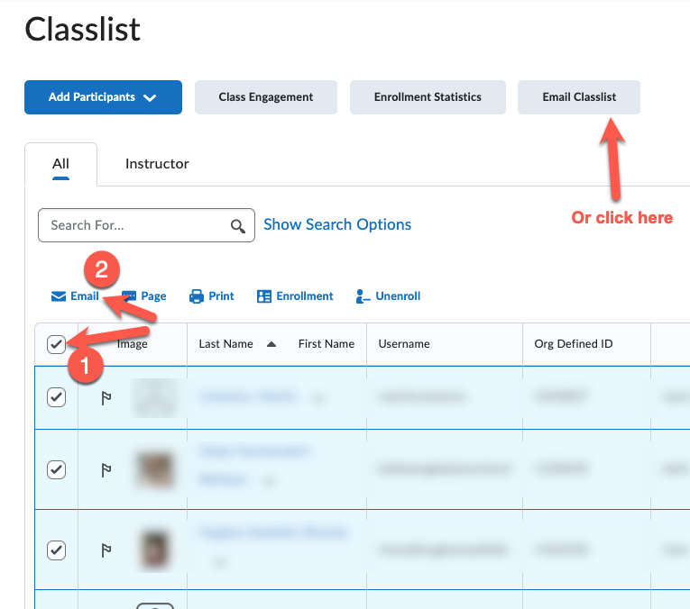

3. Click the “Email” Button
• A new email window will open within Brightspace.
4. Compose Your Email
• Add a subject (e.g., “Reminder: Upcoming Assignment Due”).
• Type your message in the body.
• Attach files if needed (e.g., syllabus, study guide).
5. Send & Confirm
• Click Send and wait for the confirmation message.
• Students will receive the email in in their Your Institution email box.

💡 Additional Tips & Tricks

✅ Use “BCC” for Privacy – Avoid displaying all student emails by default.
✅ Track Sent Emails – Emails are not stored in the “Sent” folder of your regular email but can be checked via Communications> Email > Sent Mail.
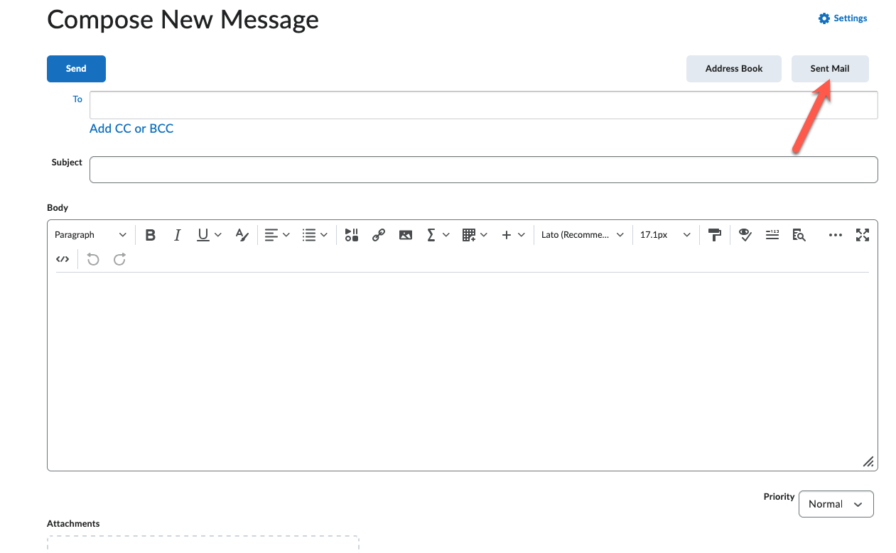

✅ Add you email address to the CC box – To receive a copy of the message for your records in your Your Institution email box.

